1.Write a Java program to print "Hello, World!" to the console.

**package** demo;

**public** **class** HelloWorld {

**public** **static** **void** main(String[] args) {

System.***out***.println("Hello, World!");

}

}

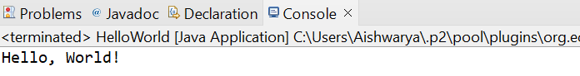

2.Write a program to find the sum of two numbers entered by the user.

**package** demo;

**import** java.util.Scanner;

**public** **class** SumOfTwoNumbers {

**public** **static** **void** main(String[] args) {

Scanner scanner = **new** Scanner(System.***in***);

// Prompt the user to enter the first number

System.***out***.print("Enter the first number: ");

**double** num1 = scanner.nextDouble();

// Prompt the user to enter the second number

System.***out***.print("Enter the second number: ");

**double** num2 = scanner.nextDouble();

// Calculate the sum

**double** sum = num1 + num2;

// Print the sum

System.***out***.println("The sum of " + num1 + " and " + num2 + " is: " + sum);

// Close the scanner

scanner.close();

}

}

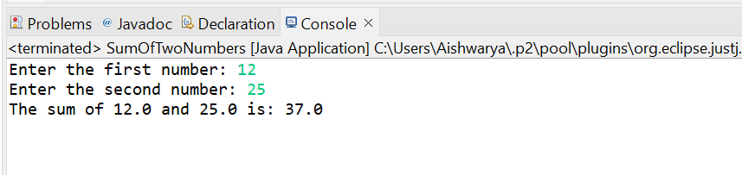

3.Write a Java program to check whether a given number is even or odd.

**package** demo;

**import** java.util.Scanner;

**public** **class** EvenOrOdd {

**public** **static** **void** main(String[] args) {

Scanner scanner = **new** Scanner(System.***in***);

// Prompt the user to enter a number

System.***out***.print("Enter a number: ");

**int** number = scanner.nextInt();

// Check if the number is even or odd

**if** (number % 2 == 0) {

System.***out***.println(number + " is even.");

} **else** {

System.***out***.println(number + " is odd.");

}

// Close the scanner

scanner.close();

}

}

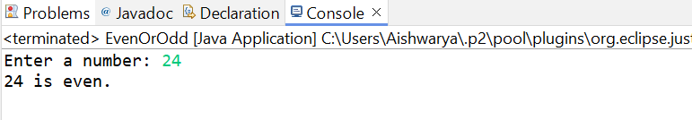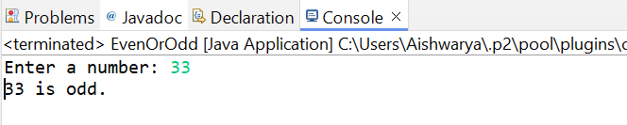

4.Write a java program to find greatest of 2 numbers.

**package** demo;

**import** java.util.Scanner;

**public** **class** EvenOrOdd {

**public** **static** **void** main(String[] args) {

// Create a Scanner object to read input from the user

Scanner scanner = **new** Scanner(System.***in***);

// Prompt the user to enter the first number

System.***out***.print("Enter the first number: ");

**int** num1 = scanner.nextInt();

// Prompt the user to enter the second number

System.***out***.print("Enter the second number: ");

**int** num2 = scanner.nextInt();

// Determine the greatest number

**int** greatest;

**if** (num1 > num2) {

greatest = num1;

} **else** {

greatest = num2;

}

// Print the greatest number

System.***out***.println("The greatest number is: " + greatest);

// Close the scanner

scanner.close();

}

}

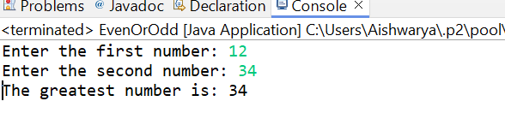

5.Write a program to implement a basic calculator that takes input as a string expression and evaluates it.

6.Write a Java program to check if a given number is even or odd.

**package** demo;

**import** java.util.Scanner;

**public** **class** EvenOddIdentifier {

**public** **static** **void** main(String[] args) {

// Create a Scanner object to read input from the user

Scanner scanner = **new** Scanner(System.***in***);

// Prompt the user to enter a number

System.***out***.print("Enter a number: ");

**int** number = scanner.nextInt();

// Check if the number is even or odd

**if** (number % 2 == 0) {

System.***out***.println(number + " is an even number.");

} **else** {

System.***out***.println(number + " is an odd number.");

}

// Close the scanner

scanner.close();

}

}

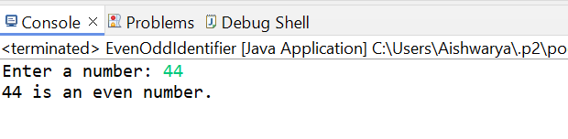

7.Create a Java program that compares two numbers and prints the larger one.

**package** demo;

**import** java.util.Scanner;

**public** **class** CompareTwoNumbers {

**public** **static** **void** main(String[] args) {

// Create a Scanner object to read input from the user

Scanner scanner = **new** Scanner(System.***in***);

// Prompt the user to enter the first number

System.***out***.print("Enter the first number: ");

**int** num1 = scanner.nextInt();

// Prompt the user to enter the second number

System.***out***.print("Enter the second number: ");

**int** num2 = scanner.nextInt();

// Compare the two numbers and print the larger one

**if** (num1 > num2) {

System.***out***.println("The larger number is: " + num1);

} **else** **if** (num1 < num2) {

System.***out***.println("The larger number is: " + num2);

} **else** {

System.***out***.println("Both numbers are equal.");

}

// Close the scanner

scanner.close();

}

}

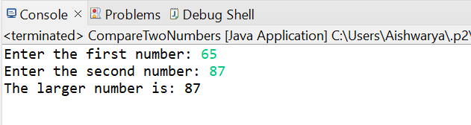

8.Write a Java program that takes an age input from the user and determines if they are eligible to vote (considering the legal voting age).

**package** demo;

**import** java.util.Scanner;

**public** **class** VotingEligibility {

**public** **static** **void** main(String[] args) {

// Create a Scanner object to read input from the user

Scanner scanner = **new** Scanner(System.***in***);

// Prompt the user to enter their age

System.***out***.print("Enter your age: ");

**int** age = scanner.nextInt();

// Determine if the user is eligible to vote

**if** (age >= 18) {

System.***out***.println("You are eligible to vote.");

} **else** {

System.***out***.println("You are not eligible to vote.");

}

// Close the scanner

scanner.close();

}

}

